DHCP

When a host (DHCP client) needs an IP configuration, it connects to a DHCP server and requests for an IP configuration. A DHCP server contains several pre-configured IP configurations. When it receives a DHCP request from a DHCP client, it provides an IP configuration to the client from all available IP configurations.

This entire process goes through the four steps: Discover, Offer, Request, and Acknowledgment. In this tutorial, we will understand these four steps in detail.

The following image shows all four steps of DHCP communication.

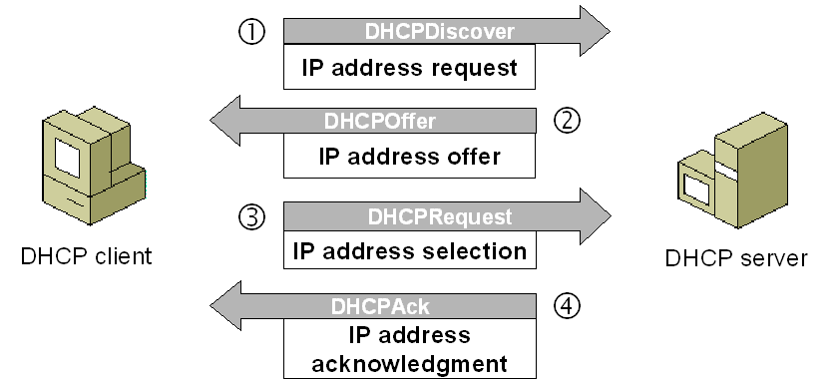

Let's understand these steps in detail.

**DHCP discovery**

When we start a device, it checks whether a valid IP configuration is available or not. If the valid IP configuration is not available, the device generates a special message known as the **DHCPDISCOVER** message and broadcasts this message on the local LAN segment.

To broadcast **DHCPDISCOVER** messages, the device uses the **0.0.0.0** and **255.255.255.255** as the source address and destination address, respectively.

The **0.0.0.0** and **255.255.255.255** are two special addresses. Any device, whether it has a valid IP configuration or not, can use these addresses to send local broadcast messages.

From these addresses, the **0.0.0.0** is used as the source address. If a device does not have the source address, it can use this address to send broadcast messages. **255.255.255.255** is the local broadcast address. Any message sent on this address is received by all hosts of the local network.

**DHCP offer**

Since the client sends the **DHCPDISCOVER** message to the local broadcast address, if a DHCP server is configured on the local network, it will also receive the message. If multiple DHCP servers are configured on the local network, they all will receive the **DHCPDISCOVER** message.

If multiple DHCP servers are available, based on their configuration, one of them or all of them can reply to the **DHCPDISCOVER** message. In reply to the **DHCPDISCOVER** message, a DHCP server sends a **DHCPOFFER** message to the client.

Since the client does not have an IP address, the DHCP server cannot send the **DHCPOFFER** message directly to the client. Because of this, the server sets the destination address to **255.255.255.255**. In other words, the server also broadcasts the **DHCPOFFER** message to the local network.

The **DHCPOFFER** message contains protocol specific information and an IP configuration. An IP configuration typically includes the following important information: the IP address for the client, the subnet mask of the proposed IP address, the IP address of the default gateway, the DNS domain name, the DNS server address or addresses, and the TFTP server address or addresses.

*Apart from these, the****DHCPOFFER****message also contains other protocol-specific information such as the lease duration and client ID. This information is required by the core functions of DHCP.*

**DHCP request**

All hosts in the local network receive the **DHCPOFFER** message. The host that sent the **DHCPDISCOVER** message accepts the **DHCPOFFER** message. Except the original host, all other hosts ignore the **DHCPOFFER**.

How does a host know whether the broadcasted DHCPOFFER message is for it or not?

The **DHCPDISCOVER** message contains the host's MAC address. When a DHCP server broadcasts a **DHCPOFFER** message, it also includes the host's MAC address in a parameter known as the **client ID**. When hosts receive the **DHCPOFFER** message, they check the client ID field in the message. If a host sees its MAC address in the client ID field, the host knows that the message is meant for it. If a host sees the MAC address of another host in the client ID field, the host knows that the message is not intended for it.

Depending on the number of DHCP servers, a host may receive multiple **DHCPOFFER** messages. If a host receives multiple **DHCPOFFER** messages, it accepts only one message and tells the corresponding server with a **DHCPREQUEST** message that it wants to use the offered IP configuration.

If only one DHCP server is available and the provided IP configuration conflicts with the client’s configuration, the client can respond with a **DHCPDECLINE** message. In this situation, the DHCP server offers another IP configuration.

When DHCP servers receive the **DHCPREQUEST** message, besides the server whose offer has been accepted, all other servers withdraw any offers that they might have made to the client and return the offered address to the pool of available addresses.

The **DHCPREQUEST** message contains a **Transaction ID** field. Just like hosts use the **client ID** field of the **DHCPOFFER** message to know whether the message is intended for them or not, DHCP servers use the **Transaction ID** field of the **DHCPREQUEST** message to know whether their offer has been accepted or not.

**DHCP acknowledgment**

When the DHCP server receives a **DHCPREQUEST** message from the client, the configuration process enters its final stage. In this stage, the server sends a **DHCPACK** message to the client.

The **DHCPACK** message is an acknowledgment to the client indicating that the DHCP server has received the **DHCPREQUEST** message of the client, and the client can use the offered IP configuration.

*In some cases, the server may also respond with a****DHCPNACK****message. The****DHCPNACK****message tells the client that the offer is no longer valid and the client needs to request an IP configuration again. Typically, this occurs when the client takes too long to respond with a****DHCPREQUEST****message after receiving a****DHCOFFER****message from the server. In such a case, the client can make a new request for another IP configuration.*

The following image shows the above steps.

